Kol Simcha Torah Gazette
For parsha terumah 5785
Volume 9 Issue 23 (Whole #437) 1 Adar 5785/ March 1, 2025
Printed L’illuy nishmas Nechama bas R’ Noach, a”h
For a free subscription, please forward your request to keren18@juno.com
Past emails can be found on the website ShabbosStories.com under Brooklyn Torah Gazette

Transforming the Food
We Eat into a “Holy” and Spiritual Experience
By Daniel Keren

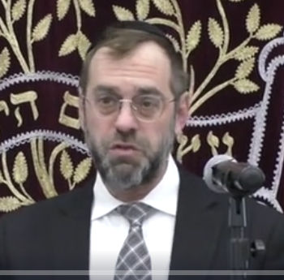
Rabbi Benzion Schiffenbauer

One of the featured speakers at the recent Martin Luther King Jr. Hakhel Yarchei Kallah Event in Flatbush was Rabbi Benzion Schiffenbauer, Rav of K’hal Bnei Torah Bais Naftali. The topic of his lecture was “The Halachos of Brachos in Everyday Life.”
Rabbi Schiffenbauer noted that so much of Yiddishkeit is based on food which appears at first glance to be so gashmius (materialistic) and that seems to be the opposite of our goal to be more ruchnius (spiritual).
The Tikun for the First Aveira of Adah Harishon
The Ben Ish Chai (Chacham Yosef Hayyim of Baghdad, 1832-1909) explains that the first aveira (sin) of mankind was Adam Harishon’s eating of the forbidden fruit [of the tree of the knowledge of good and bad.] Therefore, our tikun (spiritual remedy of that sin] is to utilize wine [and other types of food] in an elevated ruchnius, spiritual manner.
You can, Rabbi Schiffenbauer noted, enjoy wine by utilizing all five senses – (1) by seeing the drink, (2) feeling the cup in your hand, (3) smelling the fragrance of the wine, (4) hearing the wine [by clicking your cup to another person’s cup] and (5) tasting the wine when we finally drink this special beverage.
When one does this, we should reflect on the gift of these five senses that Hashem has given us to enjoy. At least once a day, perhaps when we have our first cup of coffee, we should focus our mind on thanking Hashem for the gift of being able to appreciate our five senses [that enhance the quality of our lives.]
Rabbi Schiffenbauer told of the famous story of Rav Yisroel Salanter, 1810-1883, founder of the mussar, ethic movement. He once was in Paris, the famous cosmopolitan capital of France. He entered a fancy hotel and a waiter brought him to a table and asked him what he would like to order. Rav Salanter asked for a cup of water, which was brought to him along with a very hefty bill.

The Explanation for the Bill for
the Very Expensive Cup of Water
When Rav Salanter expressed his shock at the very expensive bill for a seemingly simple cup of water, the waiter explained to him that he was not paying just for a simple cup of water. Did not the rav notice the beautiful architecture of the hotel? Did the rav not notice the orchestra playing beautiful music for his pleasure? Did not the rav notice the array of especially selected beautiful paintings by world famous artists? Did not the rav notice that the waiter brought him the water with fancy white gloves and a beautiful glass?
Yes, Rav Salanter later told his students that this was an important lesson. Hashem has given us a beautiful world and do we appreciate how much He has done to make our life enjoyable. Therefore, we owe Him the same thank you (shehakol) for an expensive steak as for the brocha one makes for a free cup of water. Without the cup of water, we can’t live. You can’t have just other types of food without the simple refreshing and life-sustaining water.
When it comes to thanking a person, Rabbi Schiffenbauer said that one has a responsibility to focus on what you are thanking that person for. And this is especially true when it comes to expressing our appreciation to Hashem.
In the Gemara, we learn that in the Days after the coming of Moshiach, we will be soveah, satisfied with eating just a little bit of food. The Rambam says that the concept of soveah, being satisfied is dependent on one’s mind. The rabbis teach us that the concept of soveah is in our power to define.

How to Eliminate the Danger of Gaivah from Food
Food (especially fancy foods) brings one to the danger of gaivah (arrogance). That is why we bentch, bless Hashem for the food that He has given us so that we realize that the food comes from Hashem and not from our own power [and culinary talents.]
The Chofetz Chaim, Rabbi Yisroel Meir Kagan in his classic sefer the Mishnah Berurah, teaches that if at a meal the host brings you an apple, if while you are still eating that initial apple, you are also brought an orange or grapes, you are able to eat those new fruits of the tree without having to make a second borei pri ha’eitz blessing since that original apple upon which you made that original blessing is still in existence and you can consider those additional fruits to have been included in the first blessing you made for the “fruit of the tree.”
However, if the first fruit was completely consumed and you are now offered an orange or a cluster of graspes, the Mishnah Berurah rules that a second blessing of borei pri ha’eitz is required.

Reprinted from the February 20, 2025 edition of the Flatbush Jewish Journal.

Thoughts that Count
for Our Parsha

They shall make Me a Sanctuary, and I will dwell among them (Ex. 25:8)
Three different types of metal were used to build the Sanctuary: gold, silver and copper. As gold is obviously the most precious, wouldn't it have been more appropriate to use only gold? Rather, the three metals allude to the three categories of Jews. Silver (kesef) alludes to tzadikim (the righteous), who continually yearn (nichsafim - from the same root as kesef) for G-d and His Torah. Gold (zahav) alludes to penitents, "in whose place even complete tzadikim cannot stand." Copper (nechoshet) alludes to those who have transgressed, who have yielded to the temptation of the nachash (serpent) that brought sin into the world. Because G-d wanted all Jews to participate in the Sanctuary's construction, all three metals were utilized. (Maayan Chai)

Reprinted from Parshat Terumah 5762/2002 edition of L’Chaim
Rav Avigdor Miller on
Protesting the Situation in Israel
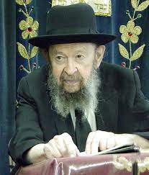

QUESTION: This Sunday there will be a big gathering on Wall Street to protest what’s going on in Eretz Yisroel. Should we go?
ANSWER: If you’re able to go there, I think you should go.
It’s a protest against the wicked judges of the Israel Supreme Court who are prejudiced against the frum Jews and they want to try to force yeshivah people to go into the army. And they say that even though the Knesses would vote against it, it’s unconstitutional. According to the constitution, they say, everybody must fight in the army.
That’s the number one thing we’re protesting. These reshaim want to break down the status quo that existed from the beginning of the State of Israel that the bnei yeshivah are patur from military service and we have to protest against that with all our koach. And Hakadosh Baruch Hu should be מפיר עצת רשעים. We daven that You should frustrate the attempts of these reshaim.
And another thing the reshaim are doing. They’re yielding to the pressure of the money of the Reformers who are sending huge funds into Eretz Yisroel and they are trying to push Reformers into the religious councils. In every neighborhood there is a religious council that supervises certain religious frum matters of observation, of kashrus and so on. And the reformers want to put women and Reform Jews there, which means they’ll break it up entirely and make it a hefkervelt.
They want that goyim who are married to Jews should be registered as Jews, like the Reformers say – patrilineal. Even though the mother was a gentile the child is a Jew because the father is a Jew, which is against the halachah. And they’re trying to make them full-fledged Jews in Eretz Yisroel.
So, we’re suffering from them terribly. It’s a great sakanah. The Supreme Court today is on the first firing line of our enemies. They’re the worst enemies of all. And so, we say, “Hakadosh Baruch Hu, תעקר ותשבר ותמגר, You should destroy those reshaim as quickly as possible.”
Say amen.

Reprinted from a recent email of Toras Avigdor, - (based on a Thursday night tape from February 25, 1999.)

More Thoughts that
Count for Our Parsha

You shall also make a table ("shulchan") (Ex. 25:23)
The numerical equivalent of the Hebrew word "shulchan" is 388, the same as the phrase "l'Moshiach," "for [the era of] Moshiach." In the Messianic era, all of the Temple's vessels and implements that have been plundered or hidden away will be restored for use in the Divine service.,(Chomat Anach)

You shall set the shew bread upon the table before Me always (Ex. 25:30)
Ever since the world was created out of nothingness, G-d's blessings can only come down when there is a physical object or vessel to contain them. As the function of the table in the Holy Temple was to influence abundance among the Jewish people, physical loaves of bread were necessary as a channel for G-d's blessings.

And you shall make upright boards for the Sanctuary (Ex. 26:15)
According to the Midrash, the world was unworthy of cedar trees (out of which these boards were made); nonetheless, G-d created them for the sake of the Sanctuary and the Holy Temple. The wood of the cedar is extremely hard, symbolic of strength and inflexibility. However, this very attribute was created to be utilized for positive purposes, i.e., that a Jew must never be deterred by those who mock him. (Avnei Ezel)

Reprinted from Parshat Terumah 5762/2002 edition of L’Chaim
G-d’s Transformation of Ordinary Jews into a “Kingdom of Priests”
From the Teachings of the Lubavitcher Rebbe
Rabbi Menachem Mendel Schneerson, Zt”l

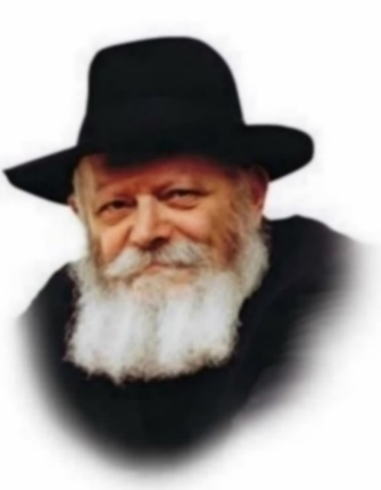

The commandment to build a Sanctuary to G-d appears in this week's Torah portion, Teruma. The mitzva was given to all Jews - men, women, and according to the Midrash, even children.
The Sanctuary in the desert was a tremendous innovation, an entirely new phenomenon that had never before existed: a physical "house" for G-d in which the Divine Presence was "enclothed" and dwelled. In fact, it is such a radical concept that King Solomon was moved to wonder, "Behold, the heaven and heaven of heavens cannot contain You; how much less this house that I have built?"
How, then, can such an amazing thing be accomplished by every Jew, even the simplest?
In actuality we find that only a handful of people were responsible for making the Sanctuary's components, such as Betzalel, whom G-d filled with "the spirit of the L-rd." Nonetheless, the Torah clearly states that the building of the Sanctuary was dependent on the actions of every Jew. But how could a single individual have the power to cause G-d's Presence to dwell in a physical structure, when the entire world is too small to contain Him?
The question becomes even stronger when we look at the wording of the command itself, "And they shall take to Me an offering." As Rashi explains, this means that the contributions for the Sanctuary had to be made for the sake of heaven, i.e., with pure intent. As not everyone can attain such an elevated level of Divine service, how could the command be directed at all Jews?
In order to understand, we must go back to the Giving of the Torah at Mount Sinai, when the Jewish people underwent an essential transformation. When G-d chose the Jews from among the nations, He took ordinary, corporeal human beings and turned them into "a kingdom of priests and a holy people."
Since then, every single Jew is connected to G-d on an essential level, which is why our Sages said, "Even though he may have sinned, he is still a Jew." Inside every Jew is a "pintele Yid," a Jewish spark that does not allow him to be separated from G-d. The true inner desire of every Jew is to obey G-d's will; if it is not always apparent, it is only because the Evil Inclination has temporary control. Moreover, even if it seems as if a Jew's motivation for serving G-d isn't entirely "pure," on the deepest, innermost level, it is.
Because the essence of the soul is always inextricably bound to G-d, every single Jew thus has to the capacity to establish a dwelling place for Him.

Reprinted from Parshat Terumah 5762/2002 edition of L’Chaim, a publication of the Lubavitcher Youth Organization. Adapted from Volume 2 of Sefer HaSichot 5752.

Rabbi Berel Wein on
Parshat Terumah 5785

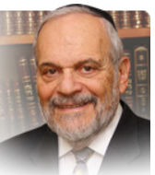

The parsha of Terumah follows those of Mishpatim and Yitro. In parshat Yitro we experienced the moment of the revelation at Mount Sinai and the granting of the Torah to the Jewish people. In parshat Mishpatim the Torah began to fill in the details of Jewish law and life, especially as they relate to human and societal behavior and the standards of such behavior that the Torah wishes us to uphold.

In this week’s parsha of Terumah, the Torah presents another challenge to human behavior – wealth, money, charity and the ability to give away what one may deem to be his or hers. The Torah demands from us the ability to donate to others, to give to great causes, to the public welfare and to be able to share with others our material possessions.

The rabbis of the Talmud stated that this is one of the major identity tests of life. Miserliness, a bad eye and an unwillingness to be able to contribute to others in need are held to be violations of Torah principles and morals. The Torah at Sinai instructed us not to steal, not to take from others what belongs to them without their explicit consent. Now the Torah raises the bar and asks us to be able to give away what we deem to be ours to others less fortunate than us or to national and religious causes that benefit us all.
All of this is implied in the request for donations to help build the holy Mishkan/Tabernacle. The L-rd could have provided us with a ready built spanking new Mishkan/Tabernacle on His own. Instead, He challenged us then and in every continuing generation of Jewish life to build a Mishkan/Tabernacle on our own and from our own resources. And that requires a proper view of our own wealth and what we do with it.

My beloved Talmud rebbe taught me over seventy years ago how to read the daily newspaper – how to filter out the golden nuggets of life and morality from the overwhelming amount of dross that fills the pages of our newspapers. There was an item in the newspaper about a baseball pitcher who gave up a guaranteed salary of twelve million dollars for 2011 and retired from the game because he felt in all honesty that he could no longer pitch effectively and did not wish to be paid for essentially doing nothing. This naturally goes against the grain of the vast majority of professional athletes whose greed and avarice is so well known. That is why it made news – it was a man bites dog story. But it indicated to me that the lesson of parshat Terumah still lives in the human heart.

To be able to walk away from money not honestly earned is a Torah value. And to share and give of our wealth to others and to the building of society, to Torah education and a national home for Jews, is also a supreme Torah value. We have to build our own Mishkan/Tabernacle constantly in every generation. The Torah’s attitude towards the sharing of our wealth is the key to such a form of Mishkan/Tabernacle building.

Reprinted from the current website of rabbiwein.com
Indebted Forever
By Rabbi Yaakov Bender

I have been privileged to be exposed to giants of the spirit throughout my life, wise men and women, and I have tried to observe and learn. If there is a common denominator, a single middah that connects all of them, it might be this one: hakaras hatov. It goes beyond gratitude, however. It reflects not just humility, but also the determination to remember, to never lose sight of a chessed performed, and to live with that recognition.
People trained to see Hashgachah pratis appreciate that each action has significance. They are aware that if a person was sent by Shamayim to help them, then part of seeing the chasdei Hashem involves seeing the role played by the Divine messenger. Marrying off a daughter is special. The night of my daughter’s chasunah, in the summer of 2011, remains etched in my memory. During the dancing, at the peak of the joy, I noticed an older man being helped into the hall, and it took me a moment to realize who it was. It was Rav Don Ungarisher, Rosh Yeshivah of Beis Medrash Elyon in Monsey, and it was difficult for him to walk.
I was astonished that he would make the effort, and I reasoned that it was because of a familial connection he had with my mother-in-law, but he told me differently. “I came out of hakaras hatov,” the Rosh Yeshivah said to me. In 1940, Reb Don and his two siblings had left Vienna for America, their parents planning to follow on the next boat.
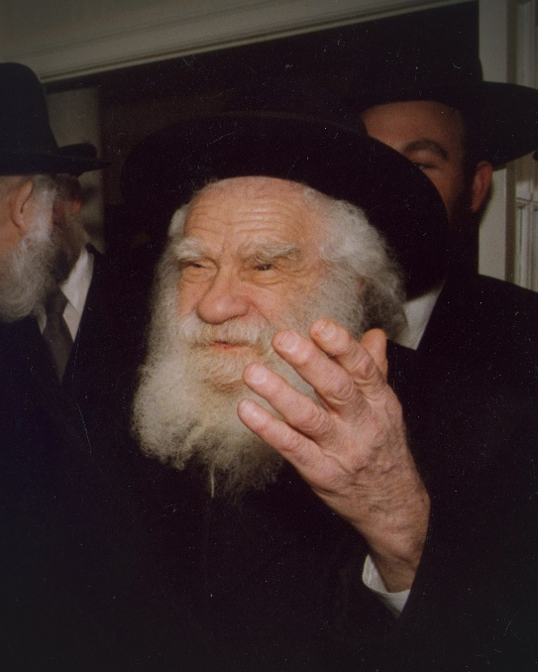
Rav Don Ungarisher

That next boat did not make it out, however, and their parents were murdered, Rachmana litzlan, leaving the three children on their own in a strange country. Although Yeshiva Torah Vodaath accepted the two boys into the yeshivah and dormitory, giving them some semblance of a home, the sister was on her own — that is, until my mother became involved. She welcomed the young girl into our family.
My mother helped her acclimate to America and succeed in Bais Yaakov. Eventually, she married Rav Manis Mandel, and enjoyed nachas from a beautiful Torah family. This had taken place in 1940, over seventy years before my daughter’s wedding. My mother was gone and Reb Don’s sister was gone, but he lived with that memory before him, along with the obligation to acknowledge it.
Later, his driver told me that the Rosh Yeshivah — who was niftar just two months later — was feeling weak that day, but he insisted on going to the chasunah just the same. The Rosh Yeshivah would not let himself forget.

Reprinted from the Parshas Mispatim 5785 edition of At the ArtScroll Shabbos Table. Excerpted from the ArtScroll book – “A Heart for Another.”

The Beracha
By Rebbetzin Chaya Sora Gertzulin

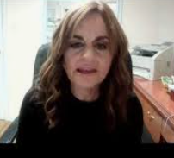

I recently heard a true- life story that spoke volumes.
It was in the mid-70s when a young successful entrepreneur went to the Lubavitcher Rebbe zt”l for a bracha. A bracha for continued success, good health and happiness, tranquility at home and peace of mind. For an all-in-all good life.
The Rebbe listened and gazed intently into the young man’s eyes. “You want Hashem’s blessings, but what are doing for Hashem. Do you keep kosher?” The young man lowered his eyes and quietly answered no. “Do you keep Shabbos?” Another no. The Rebbe continued. “If I ask you to do just one thing, will you commit?”

His Personal Na’aseh v’nishma Moment
He wanted the bracha, badly. One thing he could handle, he reasoned. He looked up and answered in the affirmative, like the Jewish people at Sinai, who answered na’aseh v’nishma, we will do and will listen. He too committed to doing before even knowing what the one thing was. It was his personal na’aseh v’nishma moment.
The Rebbe told the “bracha seeker” to observe Shabbos and bring Shabbos to his table. To light candles and make Kiddush. To stay home and make family time. To make time for Hashem. The Rebbe then gave him a bracha for hatzlacha, good health, happiness and nachas.
Together with his wife, they brought Shabbos into their lives. Every Friday night, whether he was home or away, nothing got in the way. No business meetings, no sporting events, no social engagements. One Friday night led to another, and he began to see the realization of the Rebbe’s brachos. His children grew up knowing that Friday night was special and sacred, reserved for a spiritual connection to Hashem.
How sagacious the Rebbe was. To start this man on his journey with just one thing to do—one thing that held the family together and tethered them to Hashem and His Torah. The bracha seeker realized that as his children grew older, they would be living their own lives. If not for the Rebbe’s advice, their Friday nights would mean hanging out with friends, running to the mall, or going out to movies or restaurants. How happy he was to have brought Shabbos into his, and their lives.
The Talmud (Shabbos 118b) teaches, “Kol ha’me’aneg es ha’Shabbos—Whoever delights in the Shabbos, nosnin lo mish’alos leebo, he is granted his heart’s wishes.” The Gemara is quick to cite a verse from Tehillim (37:4) that delighting in Shabbos refers to taking delight in Hashem.
In Parshas Yisro, we read of Hashem giving the Aseres HaDibros to Klal Yisroel at Sinai. It is a monumental moment in time, never to be repeated in the annals of history. A moment for all eternity.
The fourth commandment is the mitzva of Shabbos. “Zochor es yom HaShabbos l’kadsho—Remember the Shabbos Day and keep it holy” (Shemos 20:8). Zachor, to remember. Rashi comments, “T’nu lev lizkor tamid—Set your heart to remember it constantly.” Rashi further explains that we should keep Shabbos in mind as we go about our daily routine. We should try to emulate Shammai Ha’Zaken (the Elder), for whenever he spotted something special during the week, he would purchase it and set it aside for Shabbos.
Erev Shabbos is a time for Shabbos prep. As the rabbis teach, “Mi shetarach b’erev Shabbos yochal b’Shabbos— One who exerts effort on Friday, shall eat on Shabbos” (Avodah Zarah 3a). Rabbi Levi Yitzchak of Berditchev explains that by spending time preparing for a mitzva, one shows how precious the mitzva is to him, how much importance he affords it, and his eagerness to fulfill it the right way. Preparing for Shabbos is one such example.
Preparing for Shabbos, even doing mundane acts, should never be considered beneath one’s dignity. On the contrary, it brings a person honor. We learn that even if one has household help, it is a mitzvah to personally prepare something for Shabbos. The Shulchan Aruch (Orach Chaim 250:1) tells us about great sages who engaged in various chores in preparation for Shabbos. Rav Chida would cut up vegetables; Rabbah and Rav Yosef chopped wood; Rav Zeira would light the fire; and Rav Nachman would clean the house and bring out the Shabbos dishes, while putting away the weekday utensils.
It was not only gedolim of yesteryear, but today’s leaders as well. There is a heartwarming clip of Rav Dovid Feinstein zt”l, as an elderly man, shopping for Shabbos. It shows him picking up each fruit, to see if it is up to par for Shabbos.

“I’m Shopping for Shabbos”
Rav Shimshon Pincus zt”l writes that we prepare for Shabbos as if Shabbos was a “real person.” While we don’t say, “I’m shopping for Monday,” “I’m cooking for Tuesday,” we do say, “I’m shopping for Shabbos,” “I’m cooking for Shabbos.” Rav Pincus explains that when we ready our homes for Shabbos, we are inviting in the Shechinah, the Divine Presence of Hashem. Every Shabbos comes with the opportunity to grow spiritually, to become closer to Hashem. A time not just for us to eat and drink, but a time to elevate and nourish our neshama.

A Wonderful Gift in My Treasure House
The Gemara relates that HaShem told Moshe “Matana tova yesh li b’beis g’nazai, v’Shabbos shemoh—I have a wonderful gift in My treasure house, and Shabbos is its name” (Shabbos 10b). My mother, Rebbetzin Esther Jungreis a”h, wrote in her book, The Committed Life, “If we embrace the Shabbos, if we allow the Shabbos to take hold of our lives, then G-d lifts us up and invites us into His private chambers. And so, every Shabbos that is truly observed is a taste of the World to Come.”

Hashem is Sending Us a Message
The war of October 7 began on Shabbos. Even the secular day, October “7,” hints to Shabbos. Hashem is sending us a message: to strengthen ourselves through observing Shabbos. So many have understood this and have newly committed, or enhanced their commitment, to Shabbos. We derive strength from the words of Dovid HaMelech in Tehillim, Mizmor l’Dovid, which we sing every Shabbos: “Even though I walk through the valley of the shadow of death, I will fear no evil, for You are with me” (Tehillim 23:4).
May Shabbos elevate us in the unique ways only it can, and bring blessing to every aspect of our lives.

Reprinted from the Parshas Yisro 5785 edition of the TorahAnytimes Newsletter.

